LSRF-3 is equipped with Class A fast photometric probe, so the sampling speed is up to 100kHz. It fully meets the requirement of BASIC, Energy Star V2.1, IEC TR 61547-1:2020 IEC-Pst, CA CEC, ASSIST, CIE TN006-2016 CIE SVM, IEEE Std 1789 standards, etc. It is professional for flicker test of LED lights and lamps, energy-saving lamps, etc. According to EU directives 1194/2012, 2009/125 / EC, SASO2902, EU2019/2015 - EU2019/2020 and IEC60969 "Self-ballasted Lamps for General Lighting Services—Performance Requirements" and other requirements.
1. Lamp Flicker test interface (Need to work with LISUN Integrating Sphere, DC Power Source and Standard Light Source, it also can be added in LISUN LPCE-2 or LPCE-3 Integrating Sphere System):
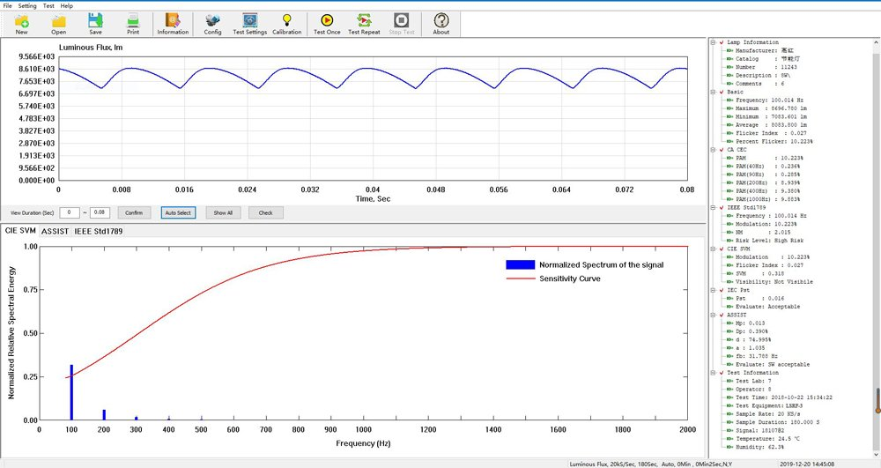
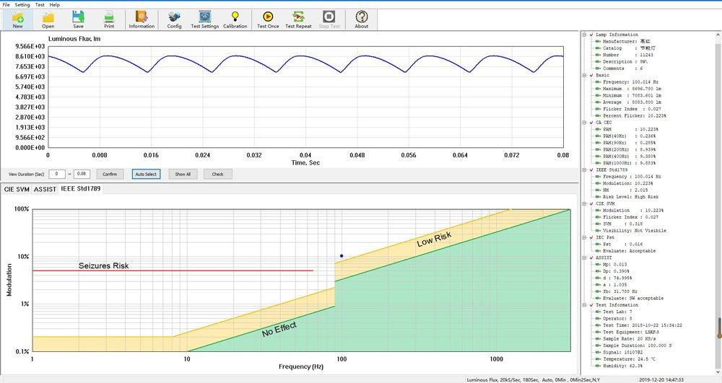
2. Lamp Start and Run-up Test: the LSRF-3 needs to work with LISUN's LSP-500VARC AC Power Source (With Trigger Function) or LSP-500VARC-Pst (IEC-Pst AC Power Source) to test the Start and Run-up time of lamps which is according to clause 11.4 Start Time Test Method & clause 11.5 Run-Up Time Test Method in the US Standards of Energy Star V2.1, and SASO2902 Table 13:
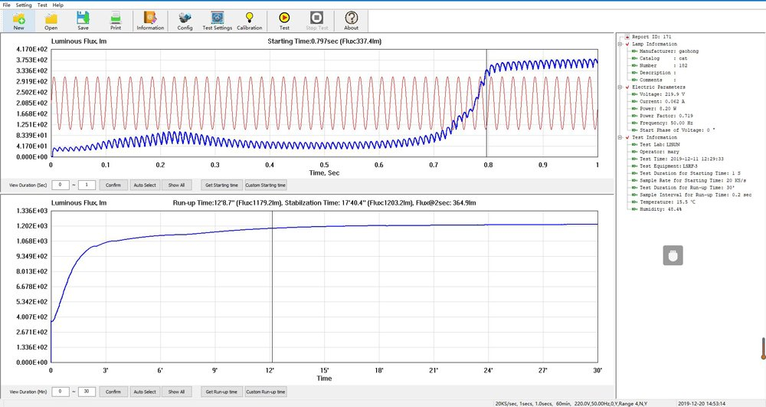
3. According to IEC TR 61547-1:2020, The LSRF-3 do the Light Pst V measure on AC Stable as below Figure 1a , and also can do the Light Pst LM(I) measure on AC Fluctuation as below Figure 1b. Note: The Light Pst LM(I) measurements need to work with LISUN's LSP-500VARC-Pst (IEC-Pst AC Power Source)
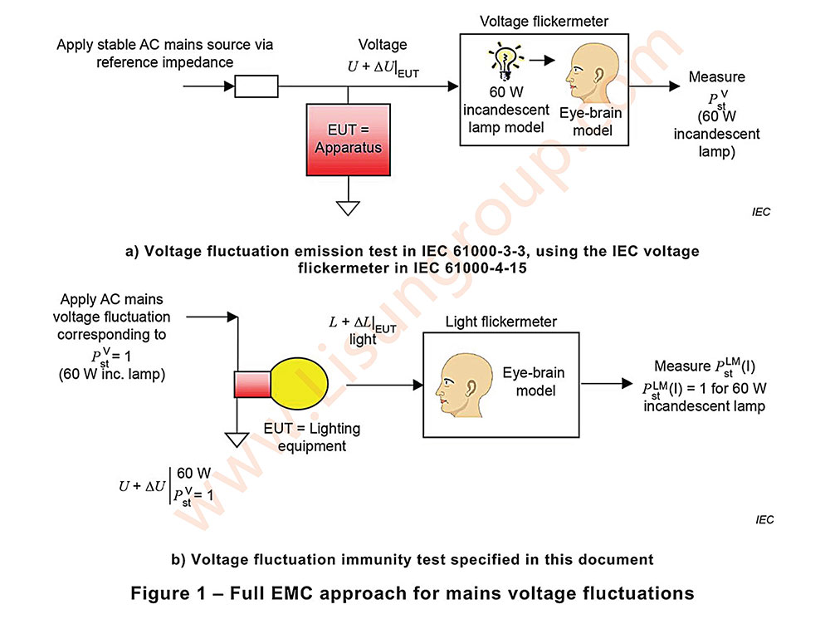 Light Pst LM and Pst LM (I) Flicker Test Principle in IEC TR 61547-1:2020 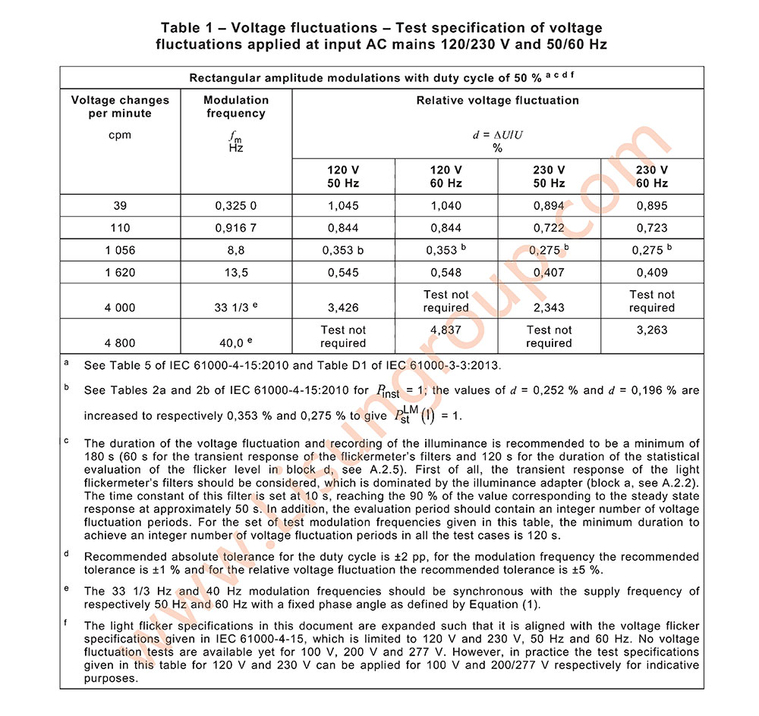 Programmable AC Power Signal Output when do Flicker Immunity Pst LM(I) test in IEC TR 61547-1:2020

